HD Digihuman Virtual Anatomy Table V1.0
Specifications

Technical  Specifications for  Hardware  (Hardware  Overview) | 1. Computer Workstation:  ·Processor: Intel Core i7 (12th generation or above).  ·RAM: 64GB DDR4 3200 MHz.  ·Storage: 4TB NVMe SSD.  ·Graphics Card: NVIDIA RTX 4080  ·Operating System: Windows 11
2. Power and Operating Conditions:
·Operating Voltage: 110V~240V.
·Frequency: 50/60Hz.
·Operating Temperature Range: -10°C to 50°C.
3. Lifting and Rotation System:
·Vertical Lifting Capacity: Maximum 430 mm.
·Rotation Angle: 0°-- 90°.
4. Display Panel Specifications:
·Screen Type: Capacitive touch screen with high transparency.
·Screen Size: 65 inches .
·Glass Specifications: High-transparency glass, 6 mm thick, with >97% transmittance.
·Resolution: 3840 × 2160
·Brightness: 700 cd/m² (typical).
·Contrast Ratio: 1300:1.
·Viewing Angle: 89° in all directions.
·Display Area: 1428.48 mm (H) × 803.52 mm (V).
·Supported Protocols: TUIO, Flash, HID multi-touch (Windows 7/8 compatible)
5. Capacitive Touch Screen Specifications:
·Response Time: First click < 16 ms.
·Touch Points: Supports 40 simultaneous touch points.
·Touch Accuracy: +2 mm across 95% of the touch area.
·Screen operation keyboard: The operation keyboard can be moved freely at the four corners of the screen
Detailed Software  Specifications | 1. Core Components:  Embedded Systems:  ·Human Anatomy: Provides comprehensive details on human anatomy.  ·Digital Anatomy System: Offers interactive digital anatomical data.  ·Slice Library: Includes digital histology and pathology slides for educational use.  ·Clinical Cases: A database of real clinical cases with interactive features.  ·Embryology Module: Covers human embryogenesis and congenital  malformations  ·Animal Anatomy: It contains the number of real animal models not less than 100.and can display the real tomographic image.
Detailed Software  Specifications | - Data Integrity and Quality:  (1).Specimen Data:  ·Includes datasets for two males and two female anatomy.  ·Based on continuous tomographic data without missing parts or artifacts.  (2). 3D Reconstruction:  ·Accuracy: Reconstructed structures with a precision of 0.1 mm.  ·Realism: Maintains true positions.  (3). Completeness:  ·Ensures all anatomical details are intact, including small structures like teeth and the appendix.
3. Interactive Features:
(1). 3D Visualization Tools:
·Rotate, zoom, and pan anatomical structures for comprehensive views.
·Adjust transparency and apply colors to differentiate between structures.
·Layer-by-layer dissection of anatomical systems.
(2). User Modes:
·Visitor Mode: Provides access to basic features.
·Login Mode: Enables advanced features such as structure customization and quick navigation.
(3). Integration:
·Seamless integration with external tools like PowerPoint for teaching purposes.
·Compatible with multi-window displays for multitasking.
4. Certifications and Compliance
Certifications:
·Registered software copyright.
·CE certification for safety and quality.
·FCC certification for compliance with electronic communication standards.
5. Functional Capabilities:
(1). Educational Features:
·Includes multimedia materials such as texts, images, videos, and 3D models.
·Comprehensive guides for teaching systematic, regional, and sectional anatomy.
(2). Diagnostic Tools:
·Supports viewing of CT/MRI scans and their corresponding 3D reconstructions.
· Measurement tools with accuracy up to 0.01 mm for lengths and angles.
(3). Dynamic Display:
·Real-time rendering and dynamic simulation of physiological processes.
·Compatible with real patient data for enhanced learning.
6. Compatibility and Customization:
(1). Software Integration:
·Fully compatible with existing systems and applications.
·No conflicts with other anatomical or teaching software.
(2). Language Support:
·Multi-language support, with anatomical names and pronunciations available.
(3). Customization:
·Users can annotate structures, save custom views, and export high-quality images or videos.
7. Advanced Functionalities:
(1). Cutting Tools:
·Supports freehand, orthogonal, and curved cutting.
·Instant cutting mode for real-time anatomical exploration.
(2). Virtual Endoscopy:
·Simulates the relationship between surface anatomy and internal structures.
·Double-screen simulation for simultaneous views.
(3). Measurement Tools:
·Instantaneous length and angle measurement tools for precise analysis
(4).Virtual endoscopic mode
·It can display the relationship between the body surface and the tissue structure under the endoscopic field of view on dual screens, simulating the endoscopic perspective for observation.
(5). Screen recording function:
·It can record the entire process of the teacher's operation screen and download the recorded video for easy use by the teacher.
8. Knowledge Management System:
(1). Educational Links:
·Connects anatomical structures to videos, images, and case studies.
·Provides detailed descriptions and adjacency information.
(2). Self-Learning Resources:
·Includes interactive exercises and quizzes for students
·Over 1800 preloaded exercises for practice.
(3). Data Preservation:
·Saves user-created materials and allows easy retrieval for future use.
9. Applications:
(1). Medical Training:
·Ideal for educating medical students and training professionals in surgical
anatomy.
(2). Interactive Learning:
·Enhances understanding of relationships between tissues and organs through hands-on exploration.
(3). Research and Analysis:
·Supports advanced research with high-precision anatomical data.
Embryology  Module  Specifications | General Framework (for Embryology Module):  ·The module must integrate videos, animations, 3D models, and courseware to provide a comprehensive teaching platform for human embryology.  · It supports both guided and self-paced learning, with interactive exercises and rich educational content
Embryology  Module  Specifications | Module Components：  A. Early Human Embryogenesis:  ·Covers 11 chapters detailing the early stages of human development, including:  1. Gametogenesis: Formation of male and female gametes.  2. Fertilization: Union of sperm and egg, leading to zygote formation.  3. Implantation: Embedding of the blastocyst into the uterine wall.  4. Formation of the Trilaminar Germ Disc: Differentiation into ectoderm, mesoderm, and endoderm layers.  5. Development of Germ Layers: Specialization of germ layers into tissues and organs.  6. Formation of Embryonic Membranes: Development of the amnion, chorion, and yolk sac.  7. Placental Development: Formation and function of the placenta.  8. Umbilical Cord and Early Circulation: Establishment of fetal blood circulation.  9. Early Neural Development: Formation of the neural plate, neural tube, and early brain structures.  10. Embryonic Determination: Early cell differentiation and fate determination.  11. Embryonic Age Estimation: Methods for calculating embryonic age and growth milestones.  B. Organogenesis:  ·Includes 16 chapters focused on the development of organ systems, such as:  1. Central Nervous System Development.  2. Head and Neck Formation.  3. Pharyngeal Arch Derivatives.  4. Cardiovascular System Formation.  5. Respiratory System Development.  6. Digestive System Formation.  7. Liver and Pancreas Development.  8. Urinary and Reproductive Systems Development.  9. Skeletal Development.  10. Muscular System Formation.  11. Sensory Organs Development.  12. Lymphatic System Formation.  13. Skin and Connective Tissue Development.  14.Endocrine Organs Formation.  15.Hematopoietic Organs Formation.  16. Limb Development.  C. Congenital Malformations:  ·Includes 16 chapters addressing:  1. Chromosomal Abnormalities.  2. Gene-Related Malformations.  3. Neural Tube Defects.  4. Congenital Heart Defects.  5. Respiratory System Malformations  6. Gastrointestinal Malformations.  7. Urogenital Malformations.  8. Limb Deformities.  9. Cleft Lip and Palate.  10. Multiple Malformation Svndromes  11. Vascular Abnormalities.  12. Sensory Organ Defects.  13. Dermatological Malformations  14. Conjoined Twins.  15. Organ Absence Syndromes.  16. Environmental Teratogens and Their Effects
Embryology  Module  Specifications | 3. Educational Resources:  1. General Videos:  ·Covering key knowledge points with interactive features such as pause, jump-to-section, and PPT linkage.  2. Knowledge Points:  ·Rich multimedia content. including text, diagrams, animations. and 3D models.  3. Exercise Bank:  ·Comprehensive database of multiple-choice questions linked to chapters.  ·Expandable for future updates.
Embryology  Module  Specifications | 4. Interactive Features:  1. 3D Models:  ·Fully interactive with 360° rotation, zooming, panning, coloring, and transparency adjustments.  ·Detailed labels and annotations for enhanced understanding.  2. Integrated Learning:  ·Seamless navigation between chapter videos, knowledge points, and courseware.  ·Facilitates a vivid representation of embryological concepts.  3. Automated Evaluation:  ·The system automatically grades objective questions and provides instant feedback.
Embryology  Module  Specifications | 5. Applications:  1. Teaching:  ·Designed for both undergraduate and postgraduate medical education.  ·Supports lectures, interactive labs, and self-guided study.  2. Research:  ·Provides high-quality embryological data for research on developmental  processes and abnormalities.  3. Clinical Relevance:  ·Aids clinicians in understanding the developmental origins of congenital malformations.
Embryology  Module  Specifications | 6. 3D Model Features:  1. Dynamic Interactions:  ·Models can be manipulated to show relationships between structures.  ·Transparency options reveal internal organization.  2. Advanced Visualization:  ·Layer-by-layer exploration of developmental stages.  ·Ability to compare normal and abnormal development in real-time.
Slice Library  Module  Specifications | 1. Search and Navigation Features :  (1). Keyword Search:  ·Allows users to search for specimens using keywords.  ·Supports fuzzy search for partial or approximate matches.  (2.) Catalog-Based Navigation:  ·Organized in a multi-level tree structure for systematic browsing.  ·Clicking a catalog reveals its subcategories and associated specimens.  (3). Browsing History:  ·Users can access their previous browsing records to revisit specimens.  ·Maintains a permanent history log for user convenience.
Slice Library  Module  Specifications | 2. Digital Slide Collection:  (1). Histology Slides:  ·Contains at least 700 high-resolution digital histology slides.  ·Slides showcase normal tissue structures with detailed labeling.  (2). Pathology Slides:  ·Includes 300 digital pathology slides covering a wide range of disease states.  ·Highlights various pathological conditions and their progression stages.  (3). Classification:  ·Slides are categorized based on type (normal/pathological).organ, and  anatomical system
Slice Library  Module  Specifications | 3. Interactive Features:  (1).Magnification Levels:  ·Supports multiple zoom levels (4X,10X,20X,40X)for detailed examination.  ·Provides a microscope-like experience.  (2). Panning and Positioning:  ·Users can move the view across the slide to focus on areas of interest.  ·Smooth transitions for exploring specific details.  (3). Labeling and Marking:  ·Enables adding annotations to slides for better understanding.  ·Marked areas can be saved for future reference.
Slice Library  Module  Specifications | 4. User Interaction:  (1). Slide Collection:  ·Users can save favorite slides into a personalized "Collection List."  ·Confirms successful addition with a "Collection Success" notification.  (2). Access to Favorites:  ·Easy retrieval of saved slides for quick access.  ·Supports viewing, editing, or removing saved items.  (3). Preset Annotations:  ·One-click navigation to preset labeled areas on the slides.  ·Users can add custom annotations and save them.
5. Display and Simulation Features:
(1). Interactive Touch and Mouse Support:
·Simulates microscope operations using touch or mouse controls.
·Allows intuitive magnification, navigation, and interaction.
(2). Preset Viewing Options:
·Offers predefined focal points on slides for fast and efficient analysis.
(3). History Navigation:
·Users can revisit recently accessed slides and toggle between them seamlessly.
(4). Contrast Adjustment:
·Enhances clarity of slides by controlling brightness and contrast settings.
6. Advanced Features for Enhanced User Experience:
(1). Interactive Exploration:
·Zoom in and out while maintaining high image quality.
·Annotate and label structures for detailed study.
(2). Complementary Features:
·Supports displaying cross-sectional views and related slides for comparative analysis.
7. Educational Applications:
(1). Teaching and Training:
·Ideal for medical education, supporting both histological and pathological learning.
·Enables comparison between normal and pathological tissue samples.
(2). Interactive Lessons:
·Facilitates the creation of interactive lessons, quizzes, and teaching materials.
(3). Clinical and Research Use:
·Assists in the analysis of tissue samples for clinical and research purposes.
8. Performance and Compatibility:
(1). Device Compatibility:
·Fully supports touchscreens and traditional computers.
(2). Data Preservation:
·Saves user data securely for easy restoration and continuous usage.
Clinical Cases Module Specifications | 1. General Overview:  · The Clinical Cases Module must be offering a comprehensive database of at least 180 real-life clinical cases.  · It provides tools for analyzing medical images, 3D reconstructions, and interactive exploration of disease features.
Clinical Cases Module Specifications | 2. Clinical Case Details:  (1). Number of Cases:  ·Over 200 cases covering a wide range of diseases and diagnostic scenarios.  (2). Case Content:  ·Disease Name: Detailed description of the condition.  ·Basic Information: Includes patient age, gender, and medical history.  ·Chief Complaint: The primary symptoms or concerns associated with the case.  ·Image Performance: Radiological data such as CT or MRI scans showing  disease manifestations.  ·Final Diagnosis: The definitive diagnosis based on clinical and imaging data.
Clinical Cases Module Specifications | 3. Image Analysis Tools:  (1). Medical Image Display:  Supports multi-view imaging, including:  ·Transverse Views (Axial)  ·Sagittal Views  ·Coronal Views  ·3D Volume Reconstructions.  (2). Image Adjustment Features:  · Manual adjustment of window width and level to enhance clarity.  ·Dynamic image rendering for better visualization of anatomical structures.  (3). Measurement Tools:  ·Tools for measuring lengths, angles, and volumes with 0.01 mm accuracy.  ·Interactive measurement of pathological areas.
Clinical Cases Module Specifications | 4. Interactive Data Features:  (1). Key Images Access:  ·Includes over 530 pre-selected key images with annotations for better understanding.  (2). 3D Reconstruction:  ·Enables 3D volumetric reconstruction of diagnostic data.  ·Provides detailed visualization of lesion characteristics.  ·Support 3D reconstruction: Supports importing new CT/MR images to reconstruct 3D structures  (3). Annotation Features:  ·Users can mark significant regions on images and add/remove annotations.  ·Saves custom annotations for future reference.
Clinical Cases Module Specifications | 5. Educational Functionality:  (1). Diagnostic Simulation:  ·Simulates clinical scenarios for step-by-step diagnostic learning.  ·Provides dynamic views of case progression for a thorough analysis.  (2). Knowledge Integration:  ·Rich educational content includes:  Disease etiology,  Symptoms and clinical presentations,  Diagnostic approaches and treatment options.  (3). Linking Images to Anatomy:  ·Allows comparison of clinical images with 3D anatomical structures.
6. Operating Features:
(1). Image Control Tools:
·Interactive controls for rotation, zooming, and adjusting image brightness/contrast.
(2). Cutting Tools:
·Supports transverse, sagittal, and freehand cutting for detailed exploration of tissue layers.
(3). Reset Options:
·Users can easily revert images to their original state for consistent analysis.
7. Customization and User Modes:
(1). Study Customization:
·Allows users to create custom study lists of cases based on specific topics.
(2). Annotations:
· Users can add personalized comments or notes to cases for educational or research purposes.
8. Certifications and Compatibility:
(1). Certifications:
·All cases are verified and supported by reputable medical institutions.
(2). Compatibility:
·Fully supports both touchscreen devices and traditional computers.
·Seamless integration with DICOM and other medical imaging standards.
9. Practical Applications:
(1). Medical Training:
·Ideal for teaching medical students and training healthcare professionals.
(2). Self-Learning:
·Enables independent study with rich, interactive content.
(3). Research and Clinical Use:
·Supports clinical decision-making and research on diagnostic imaging.
Digital Anatomy  Module  Specifications | 1. General Overview:  ·The 3D Anatomy Module must be exploring high-resolution anatomical structures of the human body.  ·Must be using real tomographic data from male and female specimens to create accurate and realistic 3D models.
Digital Anatomy  Module  Specifications | 2. Data Sources and Accuracy:  (1). Tomographic Data:  · Male Data: Over 17,000 layers with a resolution of 13700 × 6340 pixels.  · Female Data: Over 16,000 layers with a resolution of 12000 × 5700 pixels.  (2). Reconstruction Accuracy:  Precision of 0.1 mm in all dimensions, ensuring clarity and detail.  (3). Realism:  · Models reflect the true position, shape, and color of anatomical structures based on real data rather than theoretical designs.
Digital Anatomy  Module  Specifications | 3. Available Anatomical Structures:  (1). Male Anatomy:  ·Not less than 1,814 total structures across systems, including:  643 motor system  85 digestive system  64 respiratory system  370 cardiovascular system  7 urinary system  32 male reproductive system  136 sensory organs  472 nervous system  4 endocrine system  1 skin  (2). Female Anatomy:  ·Not less than 3,322 total structures, including:  1,253 motor system  114 digestive system  90 respiratory system  756 cardiovascular system  17 urinary system  35 female reproductive system  132 sensory organs  895 nervous system  7 endocrine system  23 skin and fascia
Digital Anatomy  Module  Specifications | 4. Visualization Tools:  (1). Control Features:  ·Rotation: 360-degree rotation of models.  ·Zoom and Pan: Detailed exploration of specific areas.  ·Transparency Adjustment: Reveal internal structures for deeper understanding.  ·Color Coding: Highlight and differentiate structures using custom colors.  (2). Layered Anatomy:  ·Supports layer-by-layer dissection to show relationships between organs and tissues.  ·Preserves fascia and membranes during layered exploration.  (3). Cutting Features:  ·Supports freehand, orthogonal, and curved cuts for detailed study.  ·Real-time cutting functionality for instant sectional views.
Digital Anatomy  Module  Specifications | 5. Annotation and Detailing:  (1). Anatomical Labels:  ·Over 5,300 labels for structures, providing detailed descriptions upon  selection.  ·Includes spatial, bony, and structural annotations.  (2). Bone Markings:  ·Highlights bony landmarks with color-coded annotations for easy identification.  (3). Educational Links:  ·Links to videos, case studies, and additional resources for each structure.
Digital Anatomy  Module  Specifications | 6. Measurement and Analysis Tools:  (1). Measurement Capabilities:  ·Length, angle, and volume measurements with a precision of 0.01 mm.  ·Interactive tools for manual and automatic measurements.  (2). Analytical Functions:  ·Dynamic visualization of organ changes during motion or under various conditions.  ·Simulations of physiological processes like blood flow.
Digital Anatomy  Module  Specifications | 7. Educational Features:  (1). Teaching Materials:  ·Over 250 teaching catalogs covering all nine body systems, including motor, cardiovascular, respiratory, digestive, and nervous systems.  ·Includes text, images, videos, and interactive 3D models.  (2). Saved Resources:  ·Users can save 3D views or models as high-resolution images or videos.  (3). Self-Learning Tools:  ·Interactive exercises and quizzes for students to test their understanding.  ·There are more than 140 videos: Systematic anatomy: 68, regional anatomy: 34, sectional anatomy: 39.
Digital Anatomy  Module  Specifications | 8. Integration with DICOM and Medical Imaging:  (1). DICOM Compatibility:  ·Opens and analyzes DICOM files for 3D reconstruction.  ·Supports synchronized viewing of CT/MRI images and 3D models.  (2). Clinical Data Integration:  ·Compare anatomical structures with diagnostic images for enhanced analysis.
Digital Anatomy  Module  Specifications | 9. Applications:  (1). Medical Training:  ·Perfect for teaching surgical anatomy and medical procedures.  (2). Research and Education:  ·Provides accurate data for anatomical and clinical research.  (3). Interactive Learning:  ·Helps students understand complex anatomical relationships through hands-on exploration.
Animal Anatomy  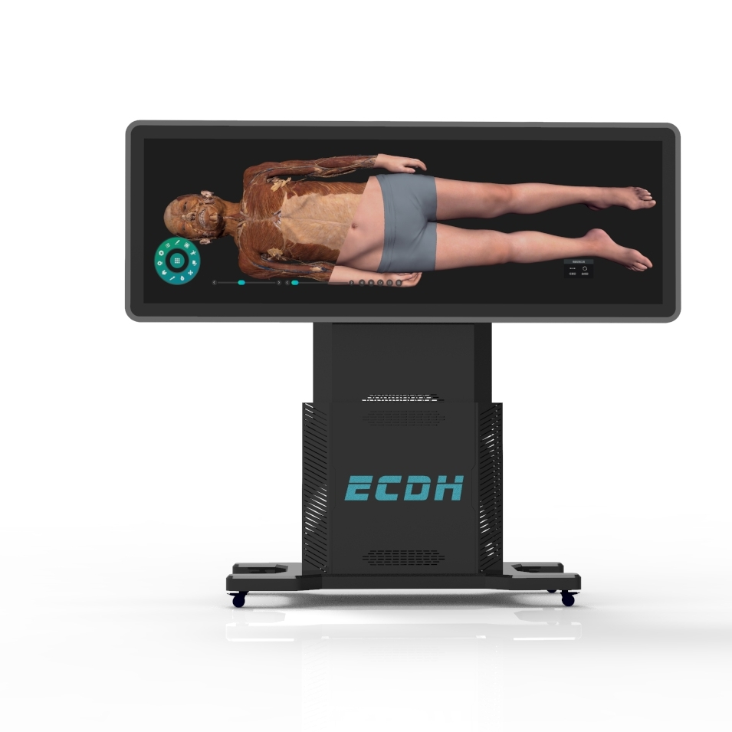 | - General Overview:  ·It can display the real tomographic image and CT/MRI images  ·The number of real animal models not less than 86.
- Educational Features:
·The system provides window adjustment for CT/MRI images
·The window width and window position can be manually adjusted according
·It can display the current case MPR scene, transverse, sagittal, coronal and volumetric reconstruction images
·It can adjust the cross-section with cut function.
3. Image Analysis Tools:
(1). Medical Image Display:
Supports multi-view imaging, including:
·Transverse Views (Axial)
·Sagittal Views
·Coronal Views
·3D Volume Reconstructions.
(2). Image Adjustment Features:
· Manual adjustment of window width and level to enhance clarity.
·Dynamic image rendering for better visualization of anatomical structures.
(3). Measurement Tools:
·Tools for measuring lengths, angles, and volumes with 0.01 mm accuracy.
·Interactive measurement of pathological areas.
